Phase 6 Production ready
Overview
Phase 6's objective is to transform the AI System's working prototype into a finished, usable product. While Phase 6 focusses on creating a system that is robust, scalable, reliable, and maintainable for real-world application, the prior phases were primarily concerned with data ingestion, model development, and system integration. This phase focusses on performance optimisation, edge case handling, evaluation, testing, maintenance, and real-world deployment of that system.
The goal of all of these components is to develop a system that will enable the AI workflow to function efficiently in the actual world while maintaining a respectable degree of accuracy, stability, and usability over time.
Subtask 1 – Performance Optimizing and caching
Objective
To improve system efficiency, reduce latency, and minimize unnecessary computational overhead.
Key optimizations Implemented
a) Model Optimization
- Selection of optimized model variants suitable for production (e.g., lightweight or distilled models).
- Reduction of inference time by tuning hyperparameters.
- Avoidance of redundant model loading by keeping models in memory during runtime.
b) Data Processing Optimization
- Batch processing of inputs instead of single-item inference where applicable.
- Streamlined preprocessing pipelines to remove unnecessary transformations.
- Efficient memory handling for large documents and datasets.
c) Caching Mechanisms
Caching is used to prevent repeated computation for frequently processed inputs.
Caching strategies include:
- Input-level caching: Previously processed documents return cached results.
- Embedding caching: Vector embeddings are stored and reused for similarity searches.
- Response caching: Frequently requested outputs are cached temporarily.
Impact
- Reduced response time
- Lower computational cost
- Improved user experience in real time systems
Subtask 2 – Edge case Handling
Objective
To ensure system reliability when handling non-ideal or unexpected inputs.
Identified Edge Cases
a) Scanned PDFs
- Scanned documents contain images instead of selectable text.
- Optical Character Recognition (OCR) is applied to extract text.
- OCR confidence thresholds are used to detect poor-quality scans.
Handling Strategy:
- Automatically route scanned PDFs through an OCR pipeline.
- Flag documents with low OCR confidence for manual review.
b) Multilingual Documents
- Documents may contain multiple languages or non-English text.
- Language detection is performed before processing.
- Translation or multilingual models are used when required.
Handling Strategy:
- Detect language using lightweight language identification models.
- Route content to language-specific pipelines or translators.
c) Data Updates and Version Changes
- Documents may be updated or replaced over time.
- Model outputs may become outdated.
Handling Strategy:
- Version control for documents and embeddings.
- Reprocessing triggers when source data changes.
- Metadata tracking for timestamps and versions.

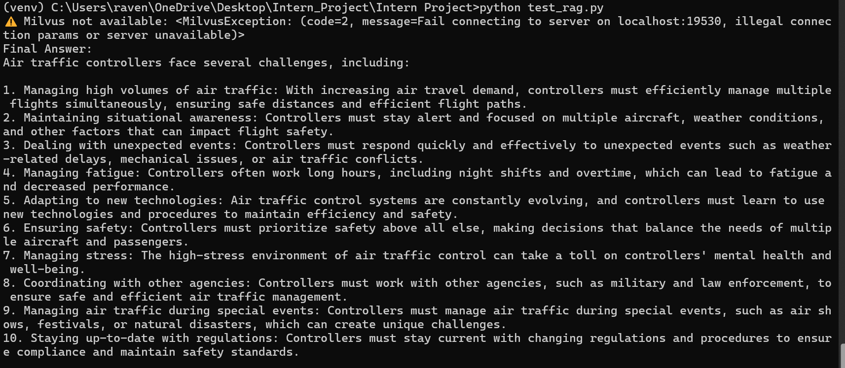
Figure 1: Subtask 2
Phase 3 – Evaluation Metrics and Testing Frameworks
Objective
To validate the system performance, accuracy and reliability before deployment
Evaluation Metrics
- Accuracy Metrics
  - Precision
  - Recall
  - F1-Score
  - Confidence scores for extracted or generated outputs
- Performance Metrics
  - Inference latency
  - Throughput (requests per second)
  - Memory usage
  - CPU/GPU utilization
- Robustness Metrics
  - Error rate on noisy inputs
  - OCR accuracy for scanned documents
  - Multilingual processing success rate
Testing Frameworks Used
- Unit testing
  - Individual modules (preprocessing, inference, post processing) tested independently
  - Ensures correctness of each component
- Integration Testing
  - Tests full AI workflow from input ingestion to output generation
  - Validates interaction between subsystems.
- Stress and Load Testing
  - Stimulates high user traffic and large data volumes
  - Identifies performance bottlenecks and failure points
- Regression testing
  - Ensures new updates do not degrade existing functionality.
  - Automated test cases run after each major change

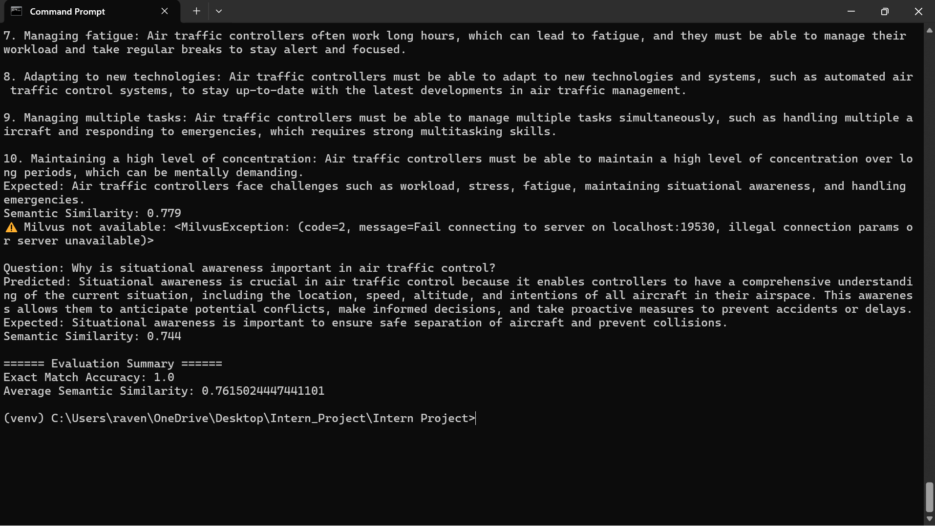
Figure 2: Subtask 3
Phase 4 – Monitoring and Development
Objective
To continuously observe system behaviour and maintain log term reliability
Monitoring Components
- System Monitoring
  - CPU, memory and storage usage
  - Inference latency and throughput
  - Error rates and failure logs
- Model Monitoring
  - Prediction confidence trends
  - Data drift detection
  - Performance degradation over time
- Logging and Alerting
  - Centralized logging for debugging and audits
  - Alerts triggered for anomalies or failures
  - Error classification for faster troubleshooting
Continuous Development
- Automated pipelines for retraining and redevelopment
- Model versioning and rollback mechanisms
- CI/CD integration for safe and repeatable releases
- Documentation updates aligned with system changes

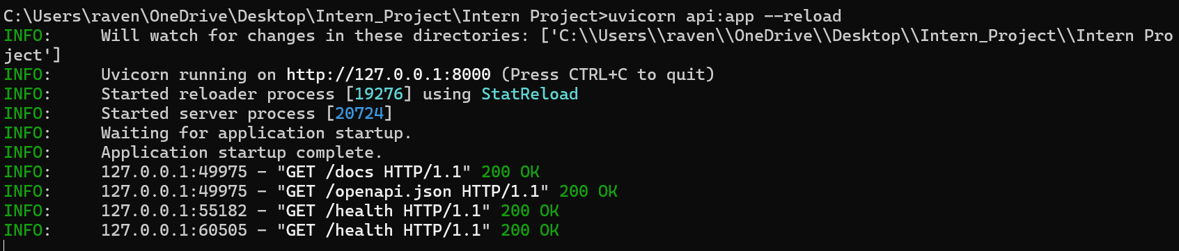
Figure 3:Subtask 4

Phase 5 – Final Capstone Project
Objective
To deliver a complete, production ready AI system that demonstrates real-world applicability.
Capstone Deliverables
- Fully functional AI-driven workflow
- Optimized and scalable architecture
- Robust handling of edge cases
- Comprehensive evaluation and testing results
- Monitoring and maintenance strategy
- Detailed technical documentation
Deployment Readiness
The system is packaged for deployment using:
- Configurable environment variables
- Secure API endpoints
- Modular architecture for extensibility
- Clear setup and execution instructions
Outcome
By the end of Phase 6, the project transitions from a development-stage prototype to a deployable AI solution, capable of operating reliably in real-world environments while meeting performance, accuracy, and maintainability standards.
Conclusion
Phase 6 represents the final and most critical stage of the AI workflow lifecycle. It ensures that the system is not only functional but also production-grade, capable of handling real-world complexity, scale, and unpredictability. Through performance optimization, robust edge case handling, systematic evaluation, continuous monitoring, and a finalized capstone deployment, the AI solution is prepared for real-world use and future enhancements.

